

Yenepoya Institute of Arts,Science,Commerce,and Management
Project – low Level Design
on
Natural Language Interface for Agriculture Infrastructure

Student Name: Aswanth M O Guided By:Mr.Praveen
Industry Mentor:Mr.Shashank

Table of Contents

- Introduction.
  - Scope of the document.
  - Intended Audience
  - System overview.
- System Design.
  - Application Design
  - Process Flow.
  - Information Flow.
  - Components Design
  - Key Design Considerations
  - API Catalogue.
- Data Design.
  - Data Model
  - Data Access Mechanism
  - Data Retention Policies
  - Data Migration
- Interfaces
- State and Session Management
- Caching
- Non-Functional Requirements
  - Security Aspects
  - Performance Aspects
- References

1. Introduction

1.1 Scope
This document explains the internal working of the Agriculture Chatbot, including modules, request flow, data handling, and session behavior.
1.2 Intended Audience
- Developers
- Testers
- Maintainers
- Reviewers
1.3 System Overview
The system includes:
- Python web server
- Shared chatbot logic
- Static agriculture data
- Website frontend
- CLI version
Both web and CLI use the same logic for consistent behavior.

2. System Design
2.1 Application Design
Module | Role
web_app.py | Handles HTTP requests/responses
command_handler.py | Processes user input
agriculture_data.py | Stores chatbot data
utils.py | Helper functions
chatbot.py | CLI chatbot
web/app.js | Frontend logic

Module Diagram
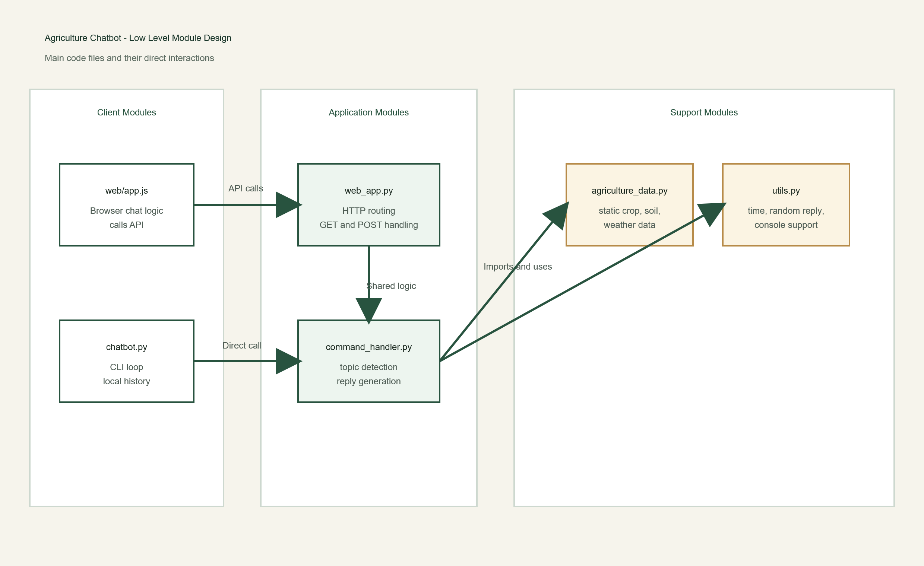

2.2 Process Flow
- User sends message via UI
- Request sent to /api/chat
- Server reads JSON
- Message processed
- Response generated
- JSON returned
- UI displays reply

Flow Diagram

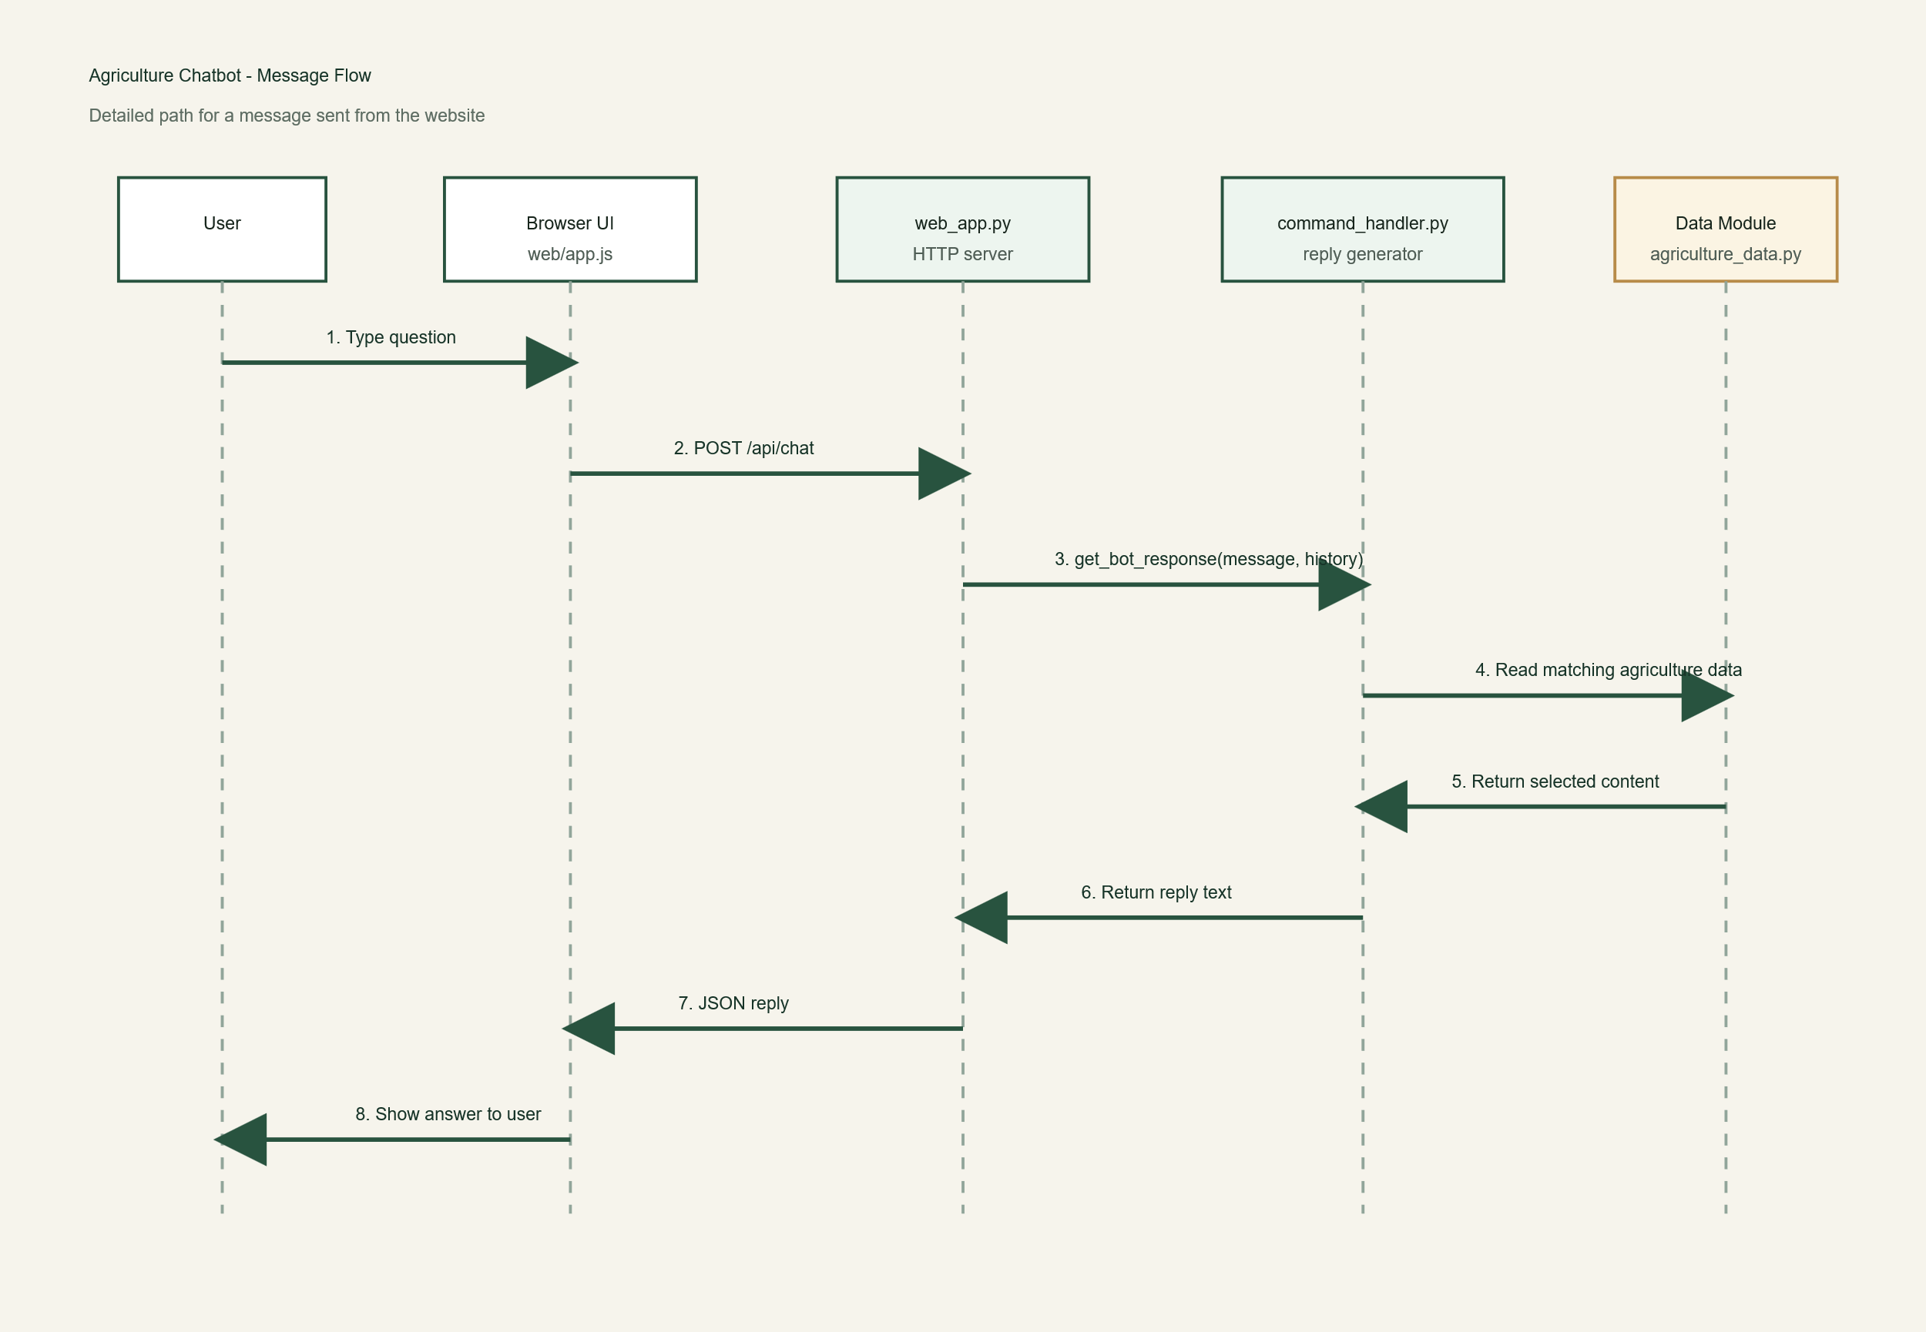

2.3 Information Flow
Request
{
"message": "weather",
"history": ["crop status"]
}
Response
{
"reply": "Sunny weather expected today."
}

2.4 Component Design
web_app.py
- Handles routes and API
- GET: serves UI + welcome data
- POST: processes chat
- Returns 404 (invalid route), 400 (bad JSON)
command_handler.py
- Detects topic using keywords
- Generates responses

- Supports:
  - crop, soil, fertilizer (dictionary)
  - weather, tips, irrigation (random)
  - time (system time)
  - history (user inputs)
agriculture_data.py
Stores:
- crop data
- soil info
- fertilizer data
- weather updates
- tips
utils.py
- Random response
- Time function
- Console helpers
chatbot.py
- CLI loop
- Stores history
- Stops on exit command
web/app.js

Manages:
- Chat history
- Quick actions
- UI state
- API calls

2.5 Key Design Points
- Shared logic (web + CLI)
- Modular structure
- Keyword-based chatbot
- In-memory data
- Simple frontend state

2.6 API Catalogue
Endpoint | Method | Purpose
/api/welcome | GET | Welcome + quick actions
/api/chat | POST | Chat response
/ | GET | Main page
/styles.css | GET | Styles
/app.js | GET | Script

3. Data Design
Data Diagram
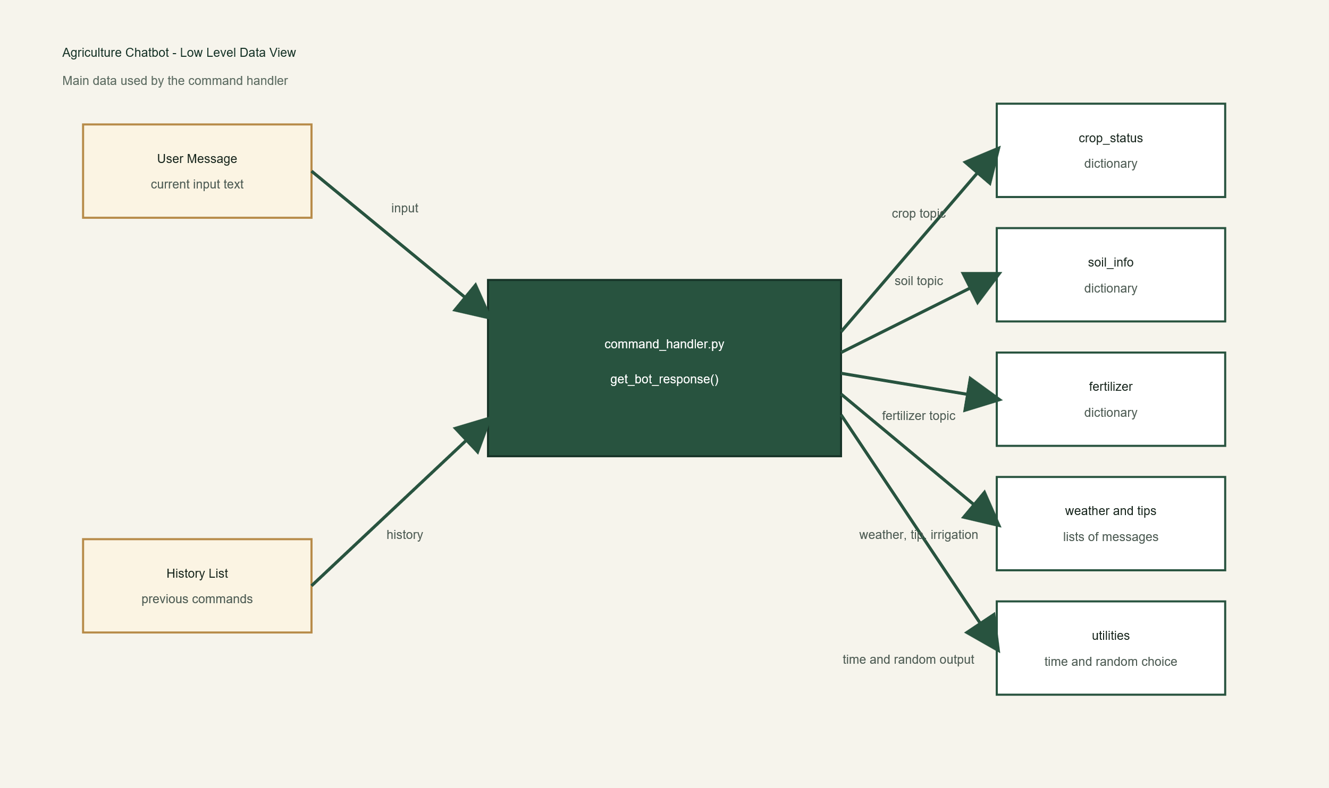
3.1 Data Model
Data | Type | Use
crop_status | dict | crop info
soil_info | dict | soil info
fertilizer | dict | fertilizer
weather_updates | list | weather
tips | list | tips
IRRIGATION_UPDATES | list | irrigation
history | list | chat history

3.2 Data Access
- Backend calls response functions
- Static data imported
- No direct frontend data access
- No database used

3.3 Data Retention
- No permanent storage
- Web history resets on refresh
- CLI history clears on exit

3.4 Data Migration
Currently not required. Future options:
- JSON
- Database
- External APIs

4. Interfaces
- Web (browser)
- CLI
- Backend API (HTTP + JSON)

5. State Management
- Stored mainly in frontend
- Backend is stateless
State includes:
- Chat history
- Quick actions
Session Flow Diagram
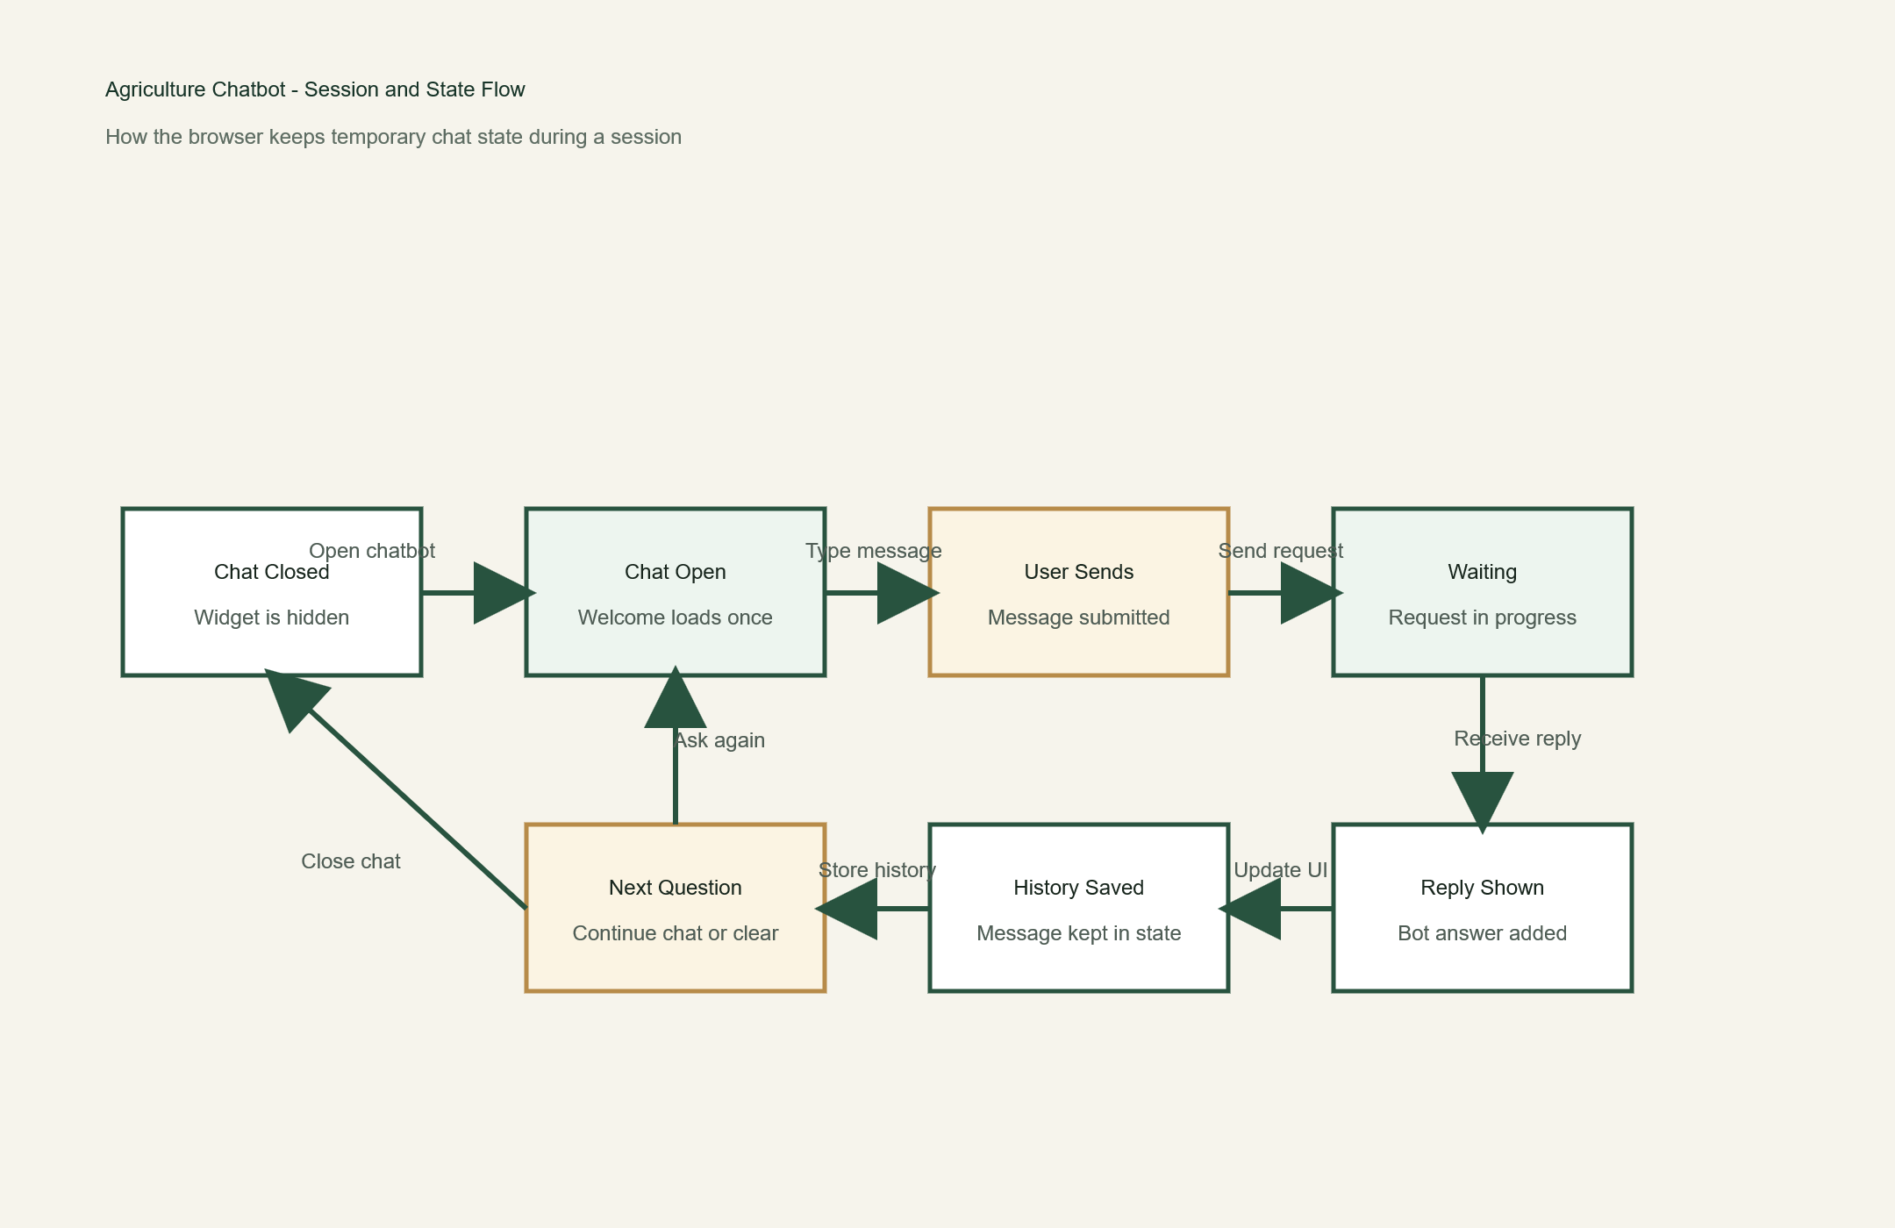

6. Caching
- No dedicated caching
- Data in memory
- Browser may cache static files

7. Non-Functional Requirements
7.1 Security
- Input/output as plain text
- Invalid routes → 404
- Invalid JSON → 400
7.2 Performance
- Small data size
- Fast keyword matching
- Lightweight system

8. References
- Backend files (web_app.py, command_handler.py, etc.)
- Frontend files (index.html, app.js, styles.css)
- README.md

